Devon Clinical Commissioning Group Learning Disabilities Mortality Review (LeDeR) Programme

Annual Report

2019

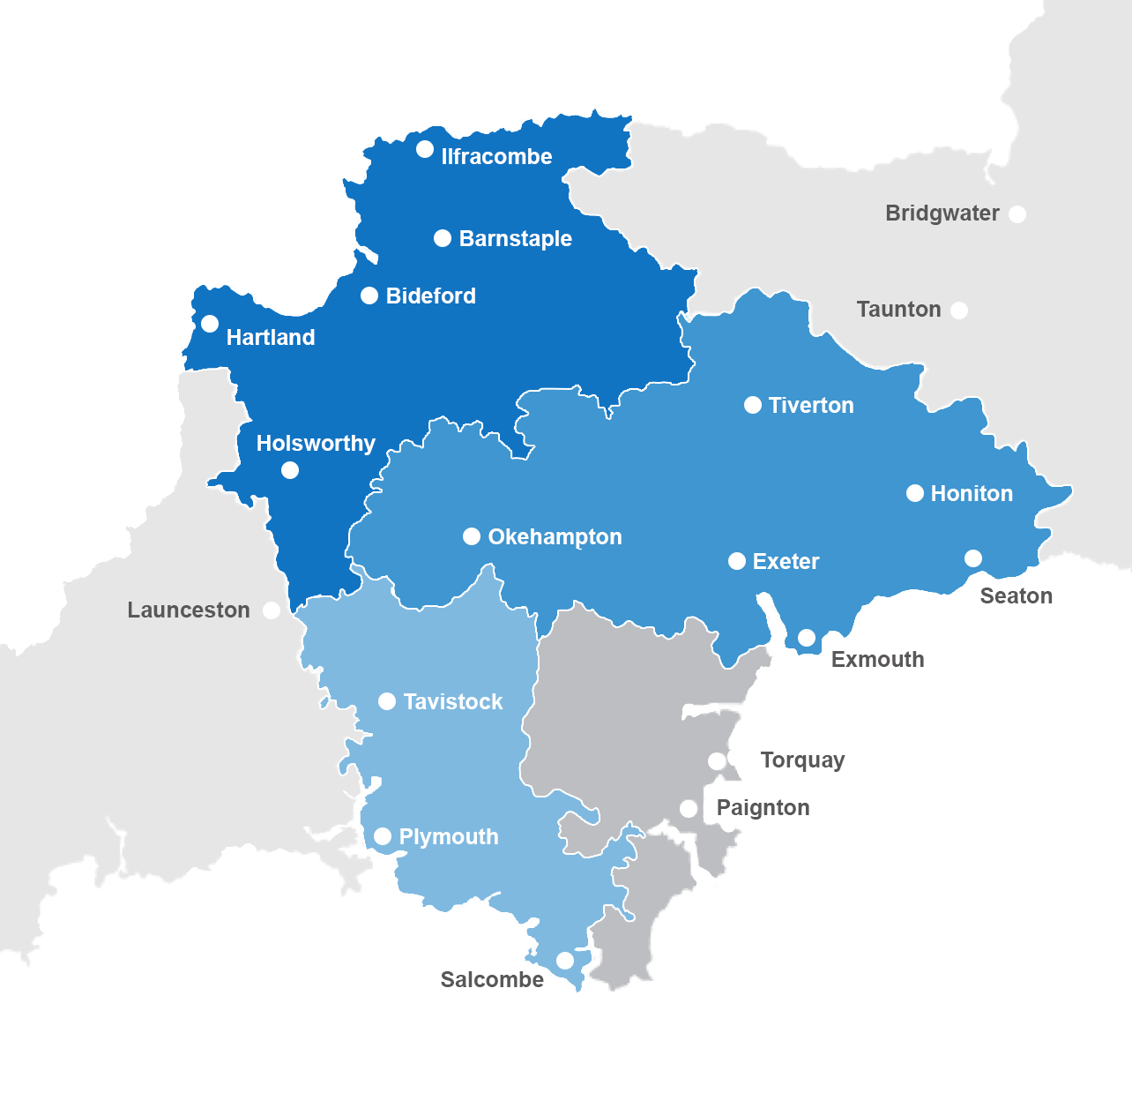

Executive Summary

This report documents the progress of the LeDeR programme in Devon and the current status. The report also highlights good practice and recommendations taken from reviews archived since inception of the programme within the CCG, (June 2017).

Introduction

This is the second Annual Report for the Devon Learning Disabilities Mortality Review (LeDeR) Programme. The information presented is in relation to notifications received between June 2017 and December 2019, with particular focus on the notifications received during 2019.

This report has been prepared by Patient Safety and Quality Support Officer, and LeDeR Coordinator, Nursing and Quality Directorate.

We would like to thank all the reviewers who have made this report possible and who have committed to the LeDeR programme not only in Devon, but nationally.

The reviews are about real people, who lived, loved and were loved in return. This work could not happen without them and so we take time to remember some of them.
Amazing, funny, full of drama, she swore (a lot). She was strong, determined, full of love, fun and spirited. (25 years old, died of parenchymal haemorrhage)
She had Down’s Syndrome, was outgoing and vivacious and quite independent. She had a mild learning disability and was well liked. She had many friends. She loved listening to music, watching TV and attending body pump and Zumba classes.
(54 years old, died of bronchopneumonia)
She had a lovely smile and was always eager to greet people, together with a bubbly personality. She worked as a volunteer in a charity shop, and in a café. (61 years old, died of aspiration pneumonia)
He was an avid Arsenal supporter and a Doctor Who fan. His room reflected his interests and he loved that the room was set up with Arsenal, Harry Potter and Dr Who. (59 years old, died of a chest infection)

The LeDeR Programme in Devon

NHS Devon Clinical Commissioning Group (CCG) has responsibility for delivering the LeDeR programme across Devon. The footprint of the programme is that of the Devon Sustainability and Transformation Partnership (STP) and is part of the STP Long Term Plan.

Within Devon CCG the programme is facilitated and supported within the nursing and quality directorate. There is senior and clinical oversight alongside a dedicated LeDeR co-ordinator role and designated LeDeR reviewer.

Once notification of a learning disability (LD) death is received it is assigned a reviewer from a pool of LeDeR trained clinicians who will examine the quality of care received by the person and family / carer. Once a review is completed and graded it is signed off by a panel consisting of the Local Area Contact, (LAC), a GP and Quality Assurance Lead before being taken to the LeDeR Steering Group.

The Steering Group meet monthly and include representation from stakeholders across Devon including all acute trusts, local authorities, mental health providers and has GP representation. Through this meeting learning and recommendations are shared and providers are requested to implement actions into learning at a local level.

During 2019, the main focus for NHS Devon CCG has been to ensure that the programme is robust and resilient in order to move forward. Therefore, future plans include aligning the LeDeR process with the CCG quality assurance processes, in order to ensure that recommendations from the reviews are acted on by providers to improve access to services for people with learning disabilities. Future plans include supporting a Devon wide event to promote and share best practice by the LeDeR programme.

Deaths notified to the Devon LeDeR programme

Number of notifications received June 2017-December 2019

Month | Number of notifications | Average notifications per month
2017 (June – December) | 15 | 2.1
2018 | 33 | 2.75
2019 | 67 | 5.6
Total | 115 | -

End of December 2019 position

Status | Number | Percentage of total received | National percentage for benchmarking
Archived | 23 | 21% | 44%
In progress | 34 | 29% | 22%
With LAC for QA checking | 24 | 21% | 3%
To be allocated | 34 * | 29% | 31%
Multi Agency Reviews | 0 | 0% | 0%

*10 of which are with the with the North East Commissioning Support Unit as part of the NHSE backlog programme.

The above table highlights that as a CCG we have significantly more than the national average which require signing off by our LAC. We have recently changed LACs and implemented a new LeDeR sign off panel meeting on a weekly basis to address this difference.

Overall we can report that 42% of notifications have been reviewed and 58% require review. The NHSE backlog programme will improve this split.

The People whose deaths were notified in 2019

Gender split within notifications

2019 | Male | Female
Gender | 37 (55%) | 30 (45%)

There is no ethnic diversity in the notifications, The 2011 Census records 94.9% of Devon’s population being White British.

Age at time of death

Age at Death | Number | Percentage
4 – 10 years | 3 | 4.8
11 – 20 years | 3 | 4.8
21 -30 years | 3 | 4.8
31 – 40 years | 2 | 3
41 – 50 years | 7 | 10.5
51 – 60 years | 19 | 28.5
61 – 70 years | 16 | 23.8
71 – 80 years | 10 | 15
81 – 90 years | 3 | 4.8
Average Age = 54

The average age of death for a person with learning disabilities living in Devon was 54 years in 2019. The median age for a person with learning disabilities living in England is 60 years. The national average for the general population was 82.9 years.

Month of death

Month of death | Number | Percentage
Jan – Mar 2019 | 12 | 18
Apr – Jun 2019 | 14 | 21
Jul – Sept 2019 | 14 | 21
Oct – Dec 2019 | 12 | 18

Nationally, most deaths occur between the months of October and March. This is not the case in Devon however the difference is minimal.

Place of death

Place of Death | Number | Percentage
Hospital | 39 | 58
Usual place of residence | 24 | 36
Hospice | 1 | 1.5
Home of relative or friend | 1 | 1.5
Care home, not usual address | 1 | 1.5
Not known | 1 | 1.5

The majority of deaths occurred in a hospital setting. In the general population, this figure was around 51%. For people with learning disabilities living in Devon in 2019, 58% died in hospital. Across England, 62% of people with learning disabilities who died, did so in hospital.

Information from the completed reviews

From June 2017 – December 2019, NHS Devon CCG completed 23 reviews. These reviews were quality assured by Devon CCG and the recommendations discussed at the Steering Group which meets bi-monthly.

Grading of care received

Grade of Care | Number
1. Excellent care | 4
2. Good care | 10
3. Satisfactory care | 6
4. Care fell short of best practice but did not have adverse effect | 1
5. Care fell short and learning could result from fuller review | 0
6. Care fell short and had an adverse effect | 2

In Devon, 86.9% of the care received from June 2017 – December 2019 was graded satisfactory or above. The national figure for 2019 is not currently available, however from July 2016 – December 2018, 92% of the care received nationally was graded as satisfactory or above. This would indicate that Devon is currently slightly below the national standard of care.

Of the two reviews that were graded as 6 (care fell short and had an adverse effect), gaps and delays in care during the final hospital admission were identified. One review resulted in a Serious Incident investigation which has been forwarded to the CCG for review, as per process. The other was treated as an internal incident with investigation taking place and reported via provider governance routes.

Cause of death

The below table demonstrated cause of death recorded within each notification for those reviews which have been archived.

Cause | number
Aspiration pneumonia | 6
Chest infection | 3
Pneumonia | 2
Oesophageal cancer | 2
Pulmonary embolism | 1
bronchopneumonia | 1
Ischaemic Heart Disease | 1
Mitochondrial disease | 1
Unclear | 1
Bowel and liver cancer | 1
Cholangiocarcinoma | 1
Infected endocarditis | 1
Natural Causes | 1
Sudden Unexpected Death in Epilepsy, (SUDEP) | 1
Total | 23

Annual Health Check in the year prior to death

Of the 23 archived the below table reports how many Annual Health Checks were undertaken.

Yes | No | Not known | Total
10 | 1 | 12 | 23

People who had a Treatment Escalation Plan (TEP) in place

Of the 23 archived the below table demonstrates how many people had TEPs in place.

Yes | Not in place | Unknown | Total
16 | 5 | 2 | 23

Example of Best Practice

Examples of best practice highlighted in the reviews that were completed between June 2017 and December 2019 were;

- Evidence that a person’s wishes to die at home were acted upon.
- End of Life Planning took place in early stages.
- Prompt Speech and Language Therapy (SALT) assessments.
- Staff demonstrated care and compassion.
- Person centred working with the family and GP. Hospitals receptive to working in this way.
- Primary Care Liaison Nurses involved in dental care.
- Care and compassion from care home workers. One particular example of a care home holding a memorial so other residents could express grief.

Indicators of the Quality of Care

The below table shows the split of identified issues, (under the review template headings) for all those archived.

Identified Issues | Yes | Percent | No | Percent | Total | Percent
Someone had concerns about the death | 5 | 22% | 18 | 78% | 23 | 100%
There were delays in care. | 3 | 13% | 20 | 87% | 23 | 100%
There were problems with organisational systems. | 4 | 17% | 19 | 83% | 23 | 100%
There were gaps in the service. | 3 | 13% | 20 | 87% | 23 | 100%

The above identified issues included;

- Personal equipment not accompanying person to hospital
- Delayed pain relief
- Lack of coordination of care between providers
- Carers feeling that they were not being listened to.

Child Deaths

The LeDeR process does not review the deaths of children as this is undertaken by the Child Death Overview Panel, a statutory body. To prevent duplication of reviews, the report from the Overview Panel is uploaded to the LeDeR system. The reviewer can then pull relevant information from the report to include in the Initial Review.

At the time of this report (February 2020), no child deaths which are also part of the LeDeR programme have been completed in Devon.

Recommendations made by reviewers during 2019

The following describes the key recommendations by reviewers during 2019. These were taken forward by the Steering Group. At the time of this report, a letter had been sent to all members of the Steering Group to ask that the information be disseminated to the appropriate people within their organisation.

Annual Health Checks

The Annual Health Check can be the starting point for conversations regarding end of life care. As life expectancy for people with learning disabilities increases, consideration needs to be given to the End of Life pathway for this population. This conversation should be started sooner rather than later. Guidance around who has this conversation with the person with learning disabilities would be helpful. Annual Health Checks contribute to the care of an individual and need to be completed in a robust manner.

A pilot scheme is starting in North Devon to address the best way to audit Annual Health Checks to maintain the quality of this service.

Treatment Escalation Plans

Treatment Escalation Plans (TEPs) should never have dementia or learning disability used as a reason for being completed. Reviews found that TEPs are sometimes introduced at a very late stage during a hospital admission. It should be considered as part of the admission process.

Frailty Index

A Frailty Index pilot scheme is currently running in East Devon where a visit to the GP can generate a frailty index which gives the likelihood of that person surviving the next 12 months. This information is recorded on a data base. The frailty index can be used to initiate conversations regarding End of Life care.

Hospital Passports

The Hospital Passport continues to be a recurrent theme in reviews. A scheme is being developed in Plymouth by Universities Hospital Plymouth for an app to be used as part of a person’s hospital passport. This would be used alongside the paper passport and would record personal information that wasn’t already included. It has been noted that only 47% of people who have a paper hospital passport bring them into hospital.

Learning Disability Liaison Nurses

The LD liaison service does not cover nights or weekends in hospitals in Devon, if the service were extended this could optimise care. Further conversations are required to consider if this should change.

Mental Capacity Act (MCA)

MCA training, whilst being completed by staff, is not always applied correctly. NHS England are looking to make training scenario based in order to address this. Specific issues are summarised below;

- It is not always clear from the records reviewed whether an MCA assessment has been completed prior to Best Interests decisions being made. Suggestions for discussion should include use of a sticker which can record the assessment and the outcome in the records.

- Best Interest decisions and MCA assessment outcomes need to be clearly visible in records for future reference. This would prevent biases being acted on or being thought responsible for decisions.

Care Coordination

A single person to coordinate care would address problems encountered by people with learning disabilities, especially where there is no family member. It would be beneficial for people with learning disabilities to have a key worker to oversee all aspects of their care.

Change of details

A change in address can have a detrimental effect on people with learning disabilities. Changes of address should to be incorporated into care planning documentation together with any changes that may have been triggered.

Discharge Planning

Discharge planning is often taking place without the involvement of carers. Carer involvement in discharge planning should be incorporated into the provision of reasonable adjustments. Discharge planning needs to be started at the point of admission and must include dialogue with care providers.

Care of people with Epilepsy

There are concerns around the use of medication for epilepsy and mandatory training; this should be considered further.

Conclusion

Throughout 2019 the LeDeR work across Devon has continued to develop and establish across the Sustainability and Transformation Partnership, (STP). Reporting in Devon has doubled from 2018 which demonstrates positive reporting and understanding of the LeDeR programme. As a CCG we are strengthening our process to ensure action into learning is followed through; quality assurance processes used by the CCG will ensure recommendations are acted upon by providers.

